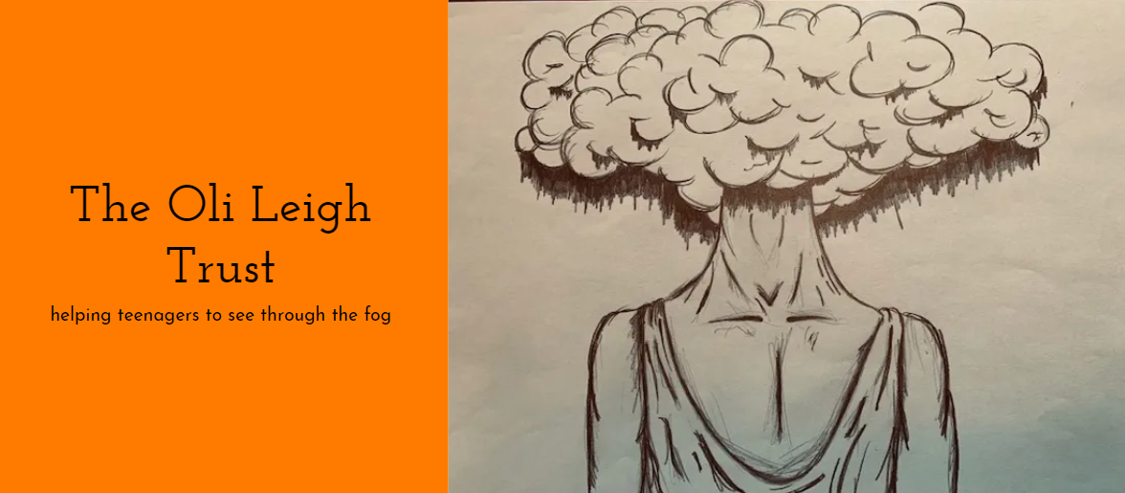GIFT AID DECLARATION



Please treat

The enclosed gift of £___________ as a Gift Aid donation OR

All gifts of money that I make today and in the future as Gift Aid donations

I confirm that I am a UK tax payer and that I have paid or will pay an amount of income tax and/or capital gains tax in the current tax year that is at least equal to the amount of tax that all the charities that I donate to will reclaim on my gifts for the tax year.

**DONOR’S DETAILS**

Title ___________ Initials(s) _________________ Surname _______________________________

Home Address ___________________________________________________________________

Postcode ___________________ Date _____________________________

Signature ____________________________________________

PLEASE NOTIFY THE OLI LEIGH TRUST IF YOU:

1. Want to cancel this declaration.
2. Change your name or home address.
3. No longer pay sufficient tax on your income and/or capital gains

▣ The Oli Leigh Trust will reclaim 25p of tax on every £1 you give. **If you pay income tax at the higher rate**, you must include all your Gift Aid donations on your Self Assessment tax return if you want to receive the additional tax relief due to you.

Please email the completed Declaration to [info@theolileightrust.org](mailto:info@theolileightrust.org) or post it to:

The Oli Leigh Trust, 164 Hansen Court, Heol Glan Rheidol, Cardiff CF10 5NY